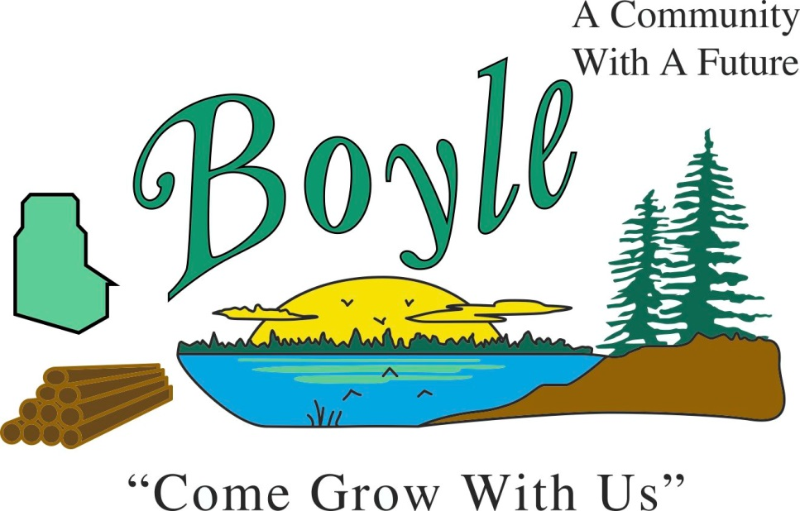
Village of Boyle
Newsletter

April 2021

.

Boyle’s Great Pumpkin Weigh Off
Register by purchasing Atlantic Giant seeds
through the GACF.

Cost: $25.00 for 1 registration or
$20.00 for 3+ registrations in the same household
When: Receive seeds May 1st, 2021, and begin growing
Weigh-off day: September 25, 2021, by the Splash Park
Age: EVERYONE

Limited registrations available.
Contact Lindsey Stanton 780-689-9365
gacf.ab.ca@gmail.com

Proceeds to the Boyle Skate Park

Paving Project

The Village of Boyle is proceeding with the 3rd and 4th Street Upgrade and plans to complete the paving portion of the upgrade this spring/summer season.
We apologize for any inconvenience this may cause and thank you in advance for your patience.
Any questions or concerns please feel free to contact the Village office at 780-689-3643 or drop in at 4800 3rd St. South.

Temporary Summer Employment

The Village of Boyle is accepting applications for temporary summer employment. The term position will commence approximately May 11, 2021, or a date agreed upon to August 31, 2021.

The scope of the work will include but not be limited to:
Mowing grass, weed trimming, garbage pickup and removal, cleaning, painting, sweeping, meter reading.
Job Requirements:
The incumbent candidates must:
*Adhere to all safety policies
*Have the ability to do lifting, bending, walking
*Be able to work in inclement weather, dusty conditions, and around unpleasant odors
*Take direction from your supervisor
*Be flexible and open to multi-tasking
*Be able to work independently with little supervision
*Maintain a detailed work completion attitude
*Must be 16 years of age or older
*Must have a valid operator’s license

For more information call Robert Jorgensen
at 780-689-3643
Or email to rjorgensen@boylealberta.com
Or Mail Village of Boyle, Box 9 Boyle, Alberta T0A 0M0
Subject: Summer Employment Position
Only those selected for an interview will be contacted
Resumes will be accepted until April 20, 2021.

Northern Lights Library System Virtual conference
May 27-28, 2021

To Register or find out more
check out the link below.

https://nlls-conference.heysummit.com/

Garbage and Recycling
Please avoid overfilling and putting loose items in the garbage cans as the slightest wind causes this debris to blow away as the carts are being dumped. For reference of proper use of the Waste Carts and the Blue Box see the back of the Village of Boyle Residential Schedule for Waste Services.
Please check out the Athabasca Regional Waste web site
www.athabascaregionalwaste.com

Emergency Contact Information
The Village is required to keep a current utility contact list in case of a gas emergency. Please ensure the Village of Boyle has your most current contact information.
You can email reception@boylealberta.com to update your current contact information or call 780-689-3643. Please include your name. address and current phone number in your email.
PERMIT REQUIREMENTS
IN THE VILLAGE OF BOYLE

Permits are required for work in the building, plumbing, gas, and electrical disciplines.

If you are not sure if you require a permit contact the Village office at 780-689-3643.

Items you require a Building Permit for are as follows: hot tubs, swimming pools, decks, woodstoves, basement developments and minor and major renovations, garages, sheds, storage buildings, new structures and mobile homes. Any structure larger than 10’x10’, any renovations that involve structural work and work that exceeds $5000.00

A permit in the Gas Discipline is required to install, alter or add to the gas system.

A permit in the Electrical Discipline is required to install, alter or add to an electrical system.

A permit in the Plumbing Discipline is required to install, alter or add to the plumbing system.

Election Nominations Open
January 1, 2021

The next municipal general election will be held on October 18, 2021. Nomination for the General Election will be open between January 1, 2021, and September 20, 2021.
Check out the Village of Boyle Website Election Information page at:
https://www.boylealberta.ca/election-2021

