Design a new
Village of Boyle Flag
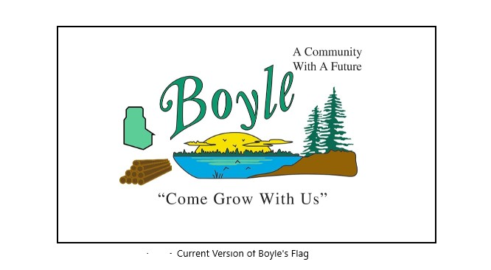
- The winner can look forward to a $100.00 cash prize.
- The contest will be open as of September 21, 2021
- The deadline for submissions is November 1, 2021.

Submissions can be addressed to:
Warren Griffin
CAO Village of Boyle
Email Warren@boylealberta.com
Mailing address:
Box 9
Boyle, AB
T0A0M0

