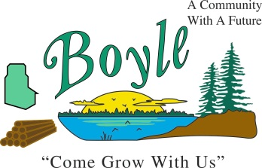
Temporary Summer Employment
The Village of Boyle is accepting applications for temporary summer employment. The term position will commence approximately May 11, 2021 or a date agreed upon to August 31, 2021. The scope of the work will include but not be limited to:
- Mowing grass, weed trimming, garbage pickup and removal
- Cleaning, painting, sweeping, meter reading
Job Requirements:
The incumbent candidates must:
- Adhere to all safety policies
- Have the ability to do lifting, bending, walking
- Be able to work in inclement weather, dusty conditions, around unpleasant odors
- Take direction from your supervisor
- Be flexible and open to multi-tasking
- Be able to work independently with little supervision
- Maintain a detailed work completion attitude
- Must be 15 years of age or older
- Must have a valid operator’s license
For more information call Robert Jorgensen at 780-689-3643
Or email to rjorgensen@boylealberta.com
Or Mail Village of Boyle, Box 9 Boyle, Alberta T0A 0M0
Subject: Summer Employment Position
Only those selected for an interview will be contacted.
Resumes will be accepted until April 20, 2021.

